Online Mobile Shopping(Mini Project)

onlineMobileSearch1.java:

**package** mini_project;

**import** java.util.Scanner;

**import** java.util.concurrent.TimeUnit;

**import** org.openqa.selenium.By;

**import** org.openqa.selenium.WebDriver;

**import** org.openqa.selenium.WebElement;

**import** org.openqa.selenium.edge.EdgeDriver;

**import** org.openqa.selenium.firefox.FirefoxDriver;

**import** org.openqa.selenium.interactions.Actions;

**public** **class** OnlineMobileSearch1 {

**public** **static** **void** main(String[] args) **throws** InterruptedException {

// Launch the browser using the configuration settings Firefox/Chrome.

Scanner sc = **new** Scanner(System.***in***);

System.***out***.println("Enter browser name: ");

String name = sc.nextLine();

WebDriver driver;

**if** (name.toLowerCase().contains("edge")) {

System.*setProperty*("webdriver.edge.driver","C:\\Users\\2317287\\eclipse-workspace\\selenium_demo\\web_browser\\msedgedriver.exe");

driver = **new** EdgeDriver();

} **else** **if** (name.toLowerCase().contains("firefox")) {

System.*setProperty*("webdriver.edge.driver","C:\\Users\\2317287\\eclipse-workspace\\selenium_demo\\web_browser\\msedgedriver.exe");

driver = **new** FirefoxDriver();

} **else** {

System.***out***.println("Browser name is incorrect");

**return**;

}

driver.manage().window().maximize();

// Read the application URL from configuration settings. (e.g. https://www.amazon.in)

driver.get("https://www.amazon.in");

driver.manage().timeouts().implicitlyWait(10, TimeUnit.***SECONDS***);

// Open the URL. User will navigate to home page of website.

// Enter the search text in search box “mobile smartphones under 30000”

Thread.*sleep*(3000);

String mob = "mobile smartphones under 30000";

WebElement Searchbox = driver.findElement(By.*id*("twotabsearchtextbox"));

Searchbox.sendKeys(mob);

Thread.*sleep*(3000);

WebElement Searchen = driver.findElement(By.*id*("nav-search-submit-button"));

Searchen.click();

// Application displays the follow message similar to following-

// o 1-24 of over 1,000 results for "mobile smartphones under 30000" (1-24 and 1000 numbers will change according to stock available on site that at the time of execution)

// In the above text, validate the search string, number of pages( e.g. 1-16), number of items (over 90,000)-Pending

Thread.*sleep*(3000);

String validatesearch = driver

.findElement(By.*xpath*("//*[@id=\'search\']/span[2]/div/h1/div/div[1]/div/div/span[3]")).getText();

// System.out.println(validatesearch);

**if** (validatesearch.contains(mob)) {

System.***out***.println("Search string is validated");

} **else** {

System.***out***.println("Search Validation Failed");

}

String validatepagesresult = driver

.findElement(By.*xpath*("//*[@id=\'search\']/span[2]/div/h1/div/div[1]/div/div/span[1]")).getText();

// System.out.println(validatepagesresult);

String[] seperate = validatepagesresult.split(" ");

String pages = seperate[0];

String result = seperate[3];

**if** (validatepagesresult.contains(pages) && validatepagesresult.contains(result)) {

System.***out***.println("The pages and result is validated");

} **else** {

System.***out***.println("The pages and result Validation failed");

}

// Click on “Sort by list” listbox.

Thread.*sleep*(3000);

WebElement SortByList = driver.findElement(By.*className*("a-dropdown-label"));

SortByList.click();

// Application should display four sort by options in the list. Check the count of options displayed.

Thread.*sleep*(3000);

String dropdownText = driver.findElement(By.*className*("a-popover-inner")).getText();

String[] text = dropdownText.split("\n");

**int** count = text.length;

// count=count-1;

System.***out***.println("the count of options: " + count);

driver.findElement(By.*className*("a-popover-inner"));

// WebDriverWait wait =new WebDriverWait(driver,20);

//

// wait.until(ExpectedConditions.visibilityOfAllElementsLocatedBy(By.className("a-popover-inner")));

// List<WebElement> list = driver.findElements(By.className("a-popover-inner"));

//

// System.out.println("Total options : " + list.size());

// for(int i=0;i<list.size();i++) {

// System.out.println(list.get(i).getText());

// if(list.get(i).getText().equals("Newest Arrivals")) {

// list.get(i).click();

// break;

// }

// }

// Select option “Newest Arrivals”

Thread.*sleep*(3000);

Actions a = **new** Actions(driver);

a.moveToElement(driver.findElement(By.*xpath*("//a[text()='Newest Arrivals']"))).click().build().perform();

String verify = driver.findElement(By.*className*("a-dropdown-prompt")).getText();

// Verify that “Newest Arrivals” option got selected correctly or not.

**if** (verify.equals("Newest Arrivals")) {

System.***out***.println("Verified the Newest Arrivals ");

} **else** {

System.***out***.println("Not verified the Newest Arrivals");

}

// Close the browser.

driver.quit();

}

}

Console Output:

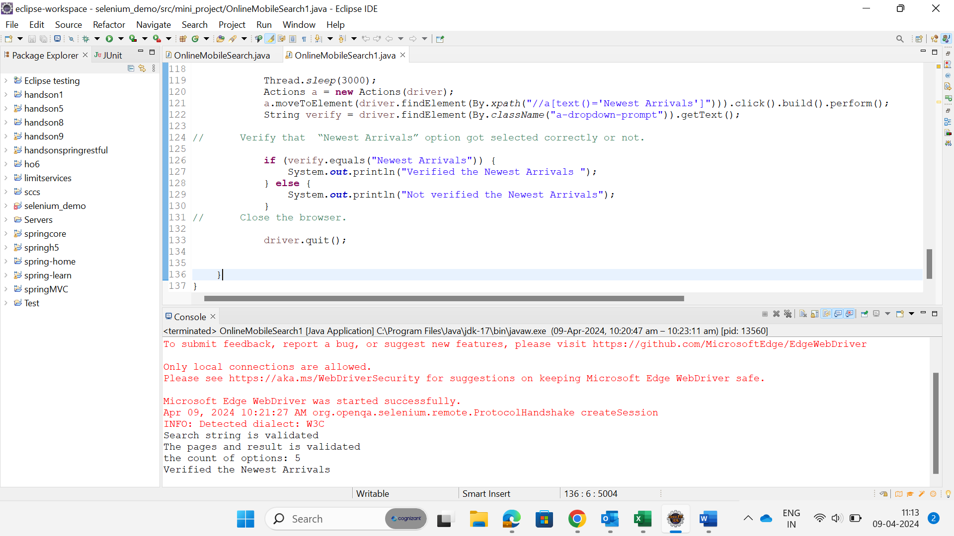

Actual output:



